FRONT END TOOLS AND METHODS

Name:Upasana Sharma Subject Code: 22CAP-606/P

UID: 22MCA20865 Section/Group:10

Semester:1ST Date:26/12/2022

WORKSHEET 3.2
Aim/Overview of the practical:
How to set the button alignment in Bootstrap?

CODE:

<!DOCTYPE html>
<html>
<head>
<meta charset="utf-8">
<meta name="viewport"
content="width=device-width, initial-scale=1, shrink-to-fit=no">

<link rel="stylesheet"
href="https://maxcdn.bootstrapcdn.com/bootstrap/4.0.0/css/bootstrap.min.css" />

<title>Aligning Buttons</title>

<style type="text/css">
html,
body {
height: 200px;
}
</style>
</head>

<body>
<h1 style="color:Blue;text-align:center;">BUTTONS </h1>
<div class="container h-100">
<div class="d-flex h-100">
<div class="align-self-start mr-auto">
<button type="button" class="btn btn-outline-danger">
Click Me!
</button>
</div>
<div class="align-self-center mx-auto">
<button type="button" class="btn btn-outline-primary">
Click Me!
</button>
</div>
<div class="align-self-end ml-auto">
<button type="button" class="btn btn-outline-success">
Click Me!
</button>
</div>
</div>
</div>

<script src="https://code.jquery.com/jquery-3.2.1.slim.min.js">
</script>
<script src=
"https://maxcdn.bootstrapcdn.com/bootstrap/4.0.0/js/bootstrap.min.js">
</script>
</body>

</html>

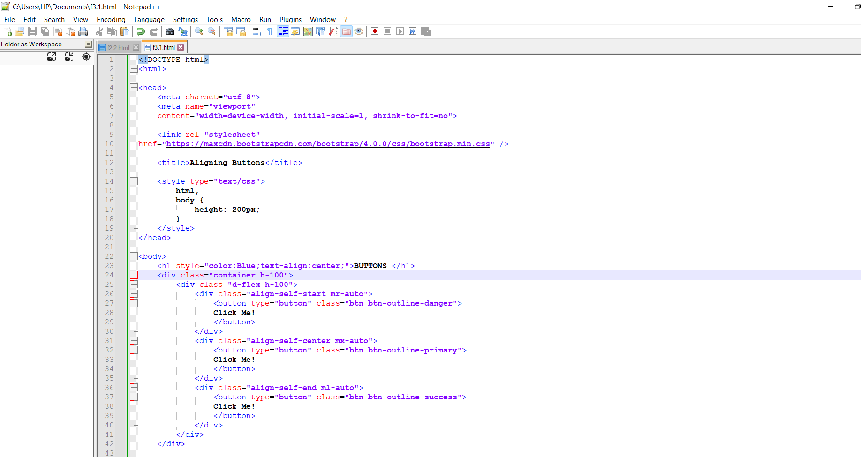

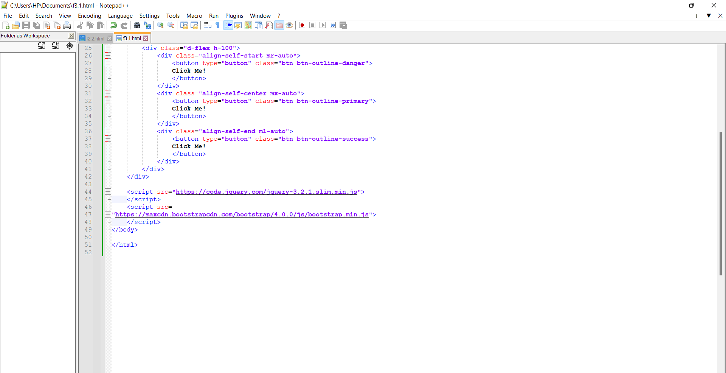

OUTPUT:

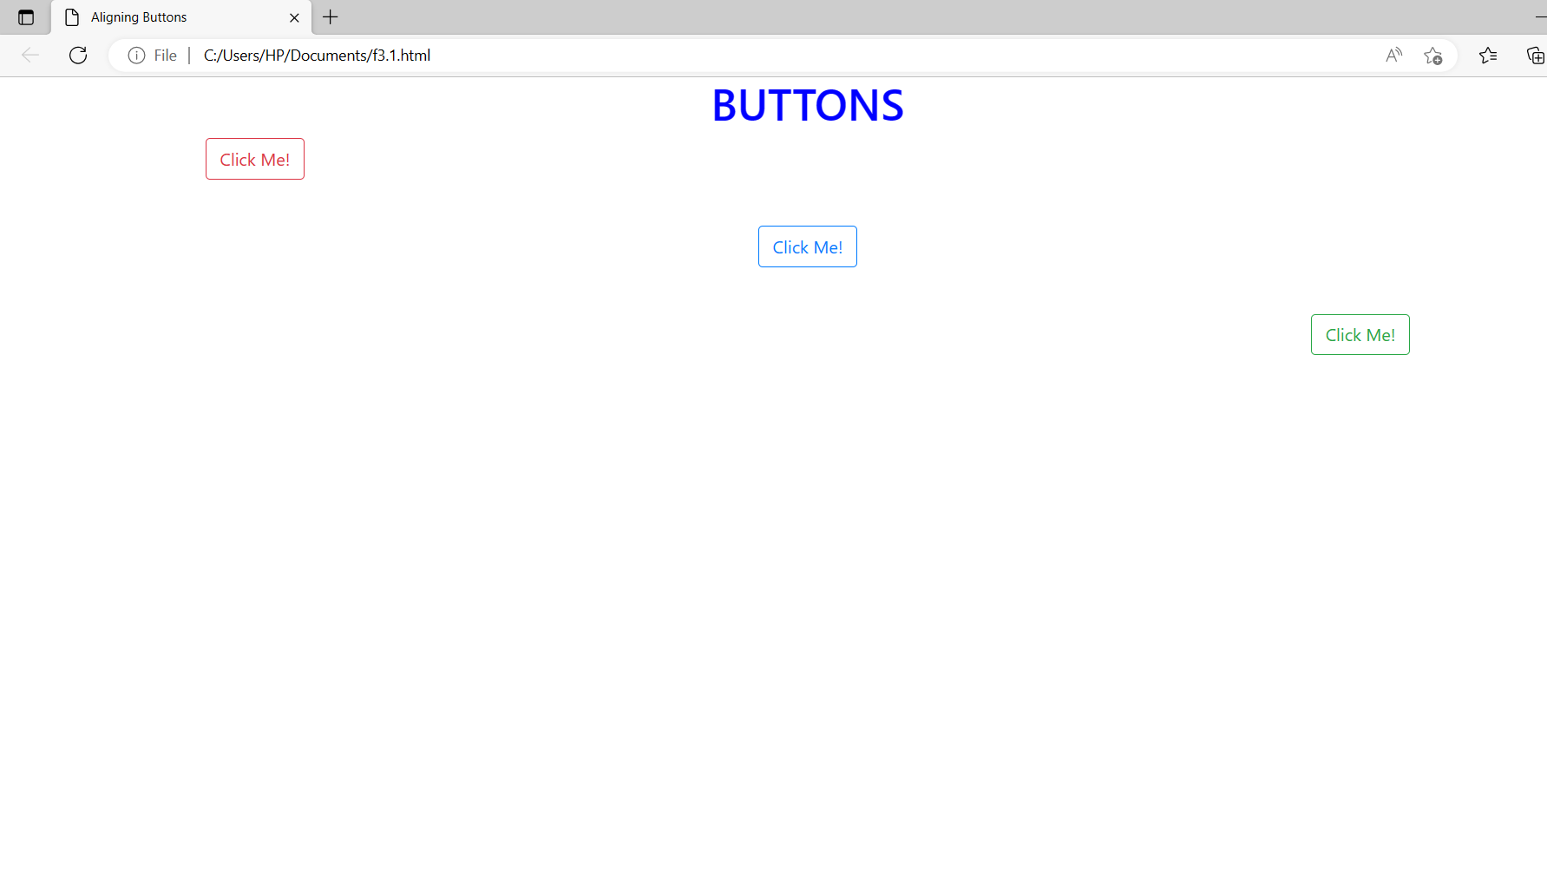

Evaluation Grid:

Sr. No. | Parameters | Marks Obtained | Maximum Marks
1. | Demonstration and Performance (Pre Lab Quiz) |  | 5
2. | Worksheet |  | 10
3. | Post Lab Quiz |  | 5

